**Experiment -1 :-** Configuration of Network Devices using Packet Tracer (Hub, Switch, Ethernet, Broadcast)

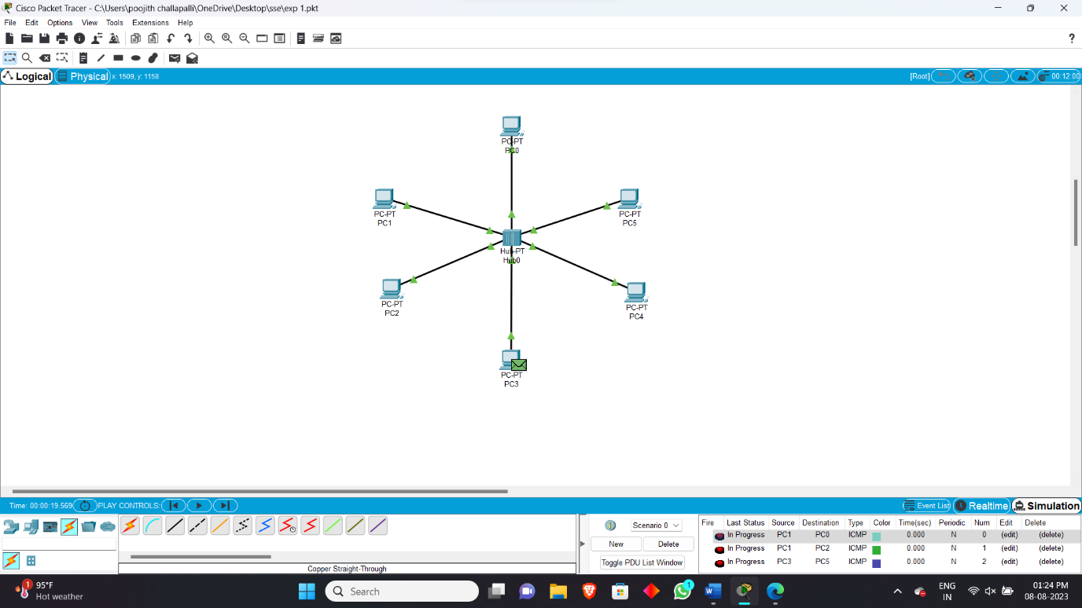

**Experiment -2 :-** Configuration of Topologies using Packet Tracer (Star, Mesh, Tree,)

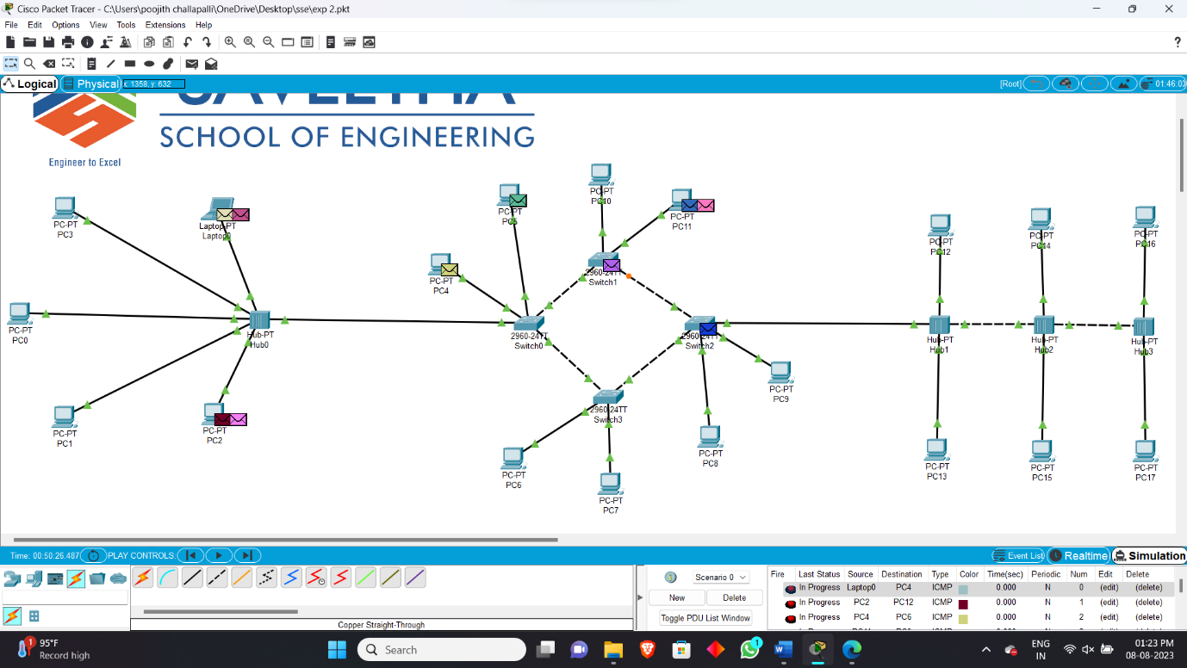

**Experiment -3 :-** Configuration of Topologies using Packet Tracer (bus, ring, hybrid,)

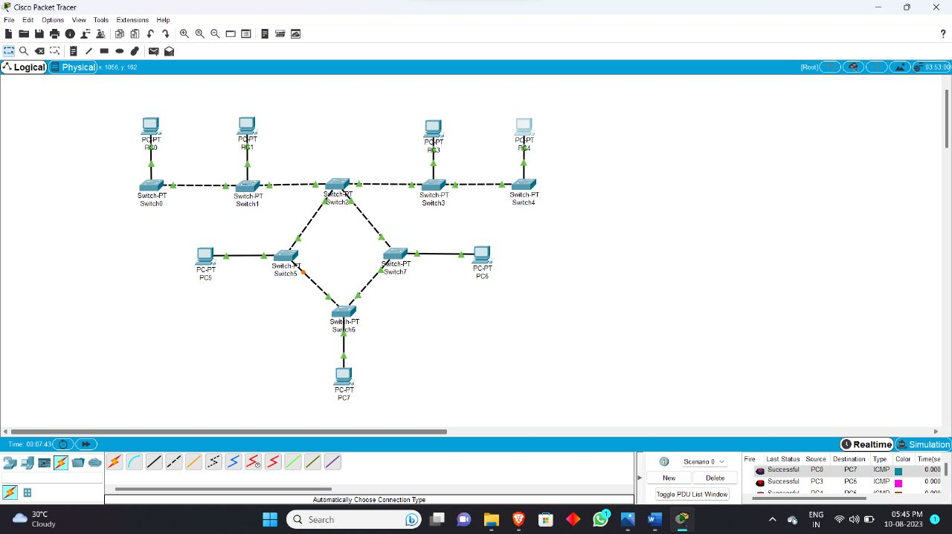

**Experiment -4 :-** Data Link Layer Traffic Simulation using Packet Tracer Analysis of CSMA/CD& CSMA/CA

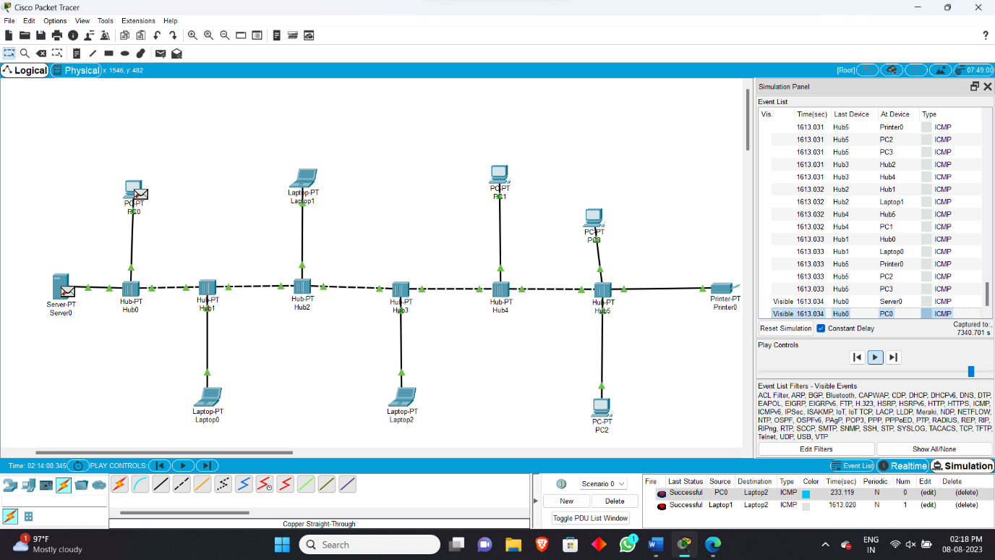

**Experiment -5 :-** Data Link Layer Traffic Simulation using Packet Tracer Analysis of ARP

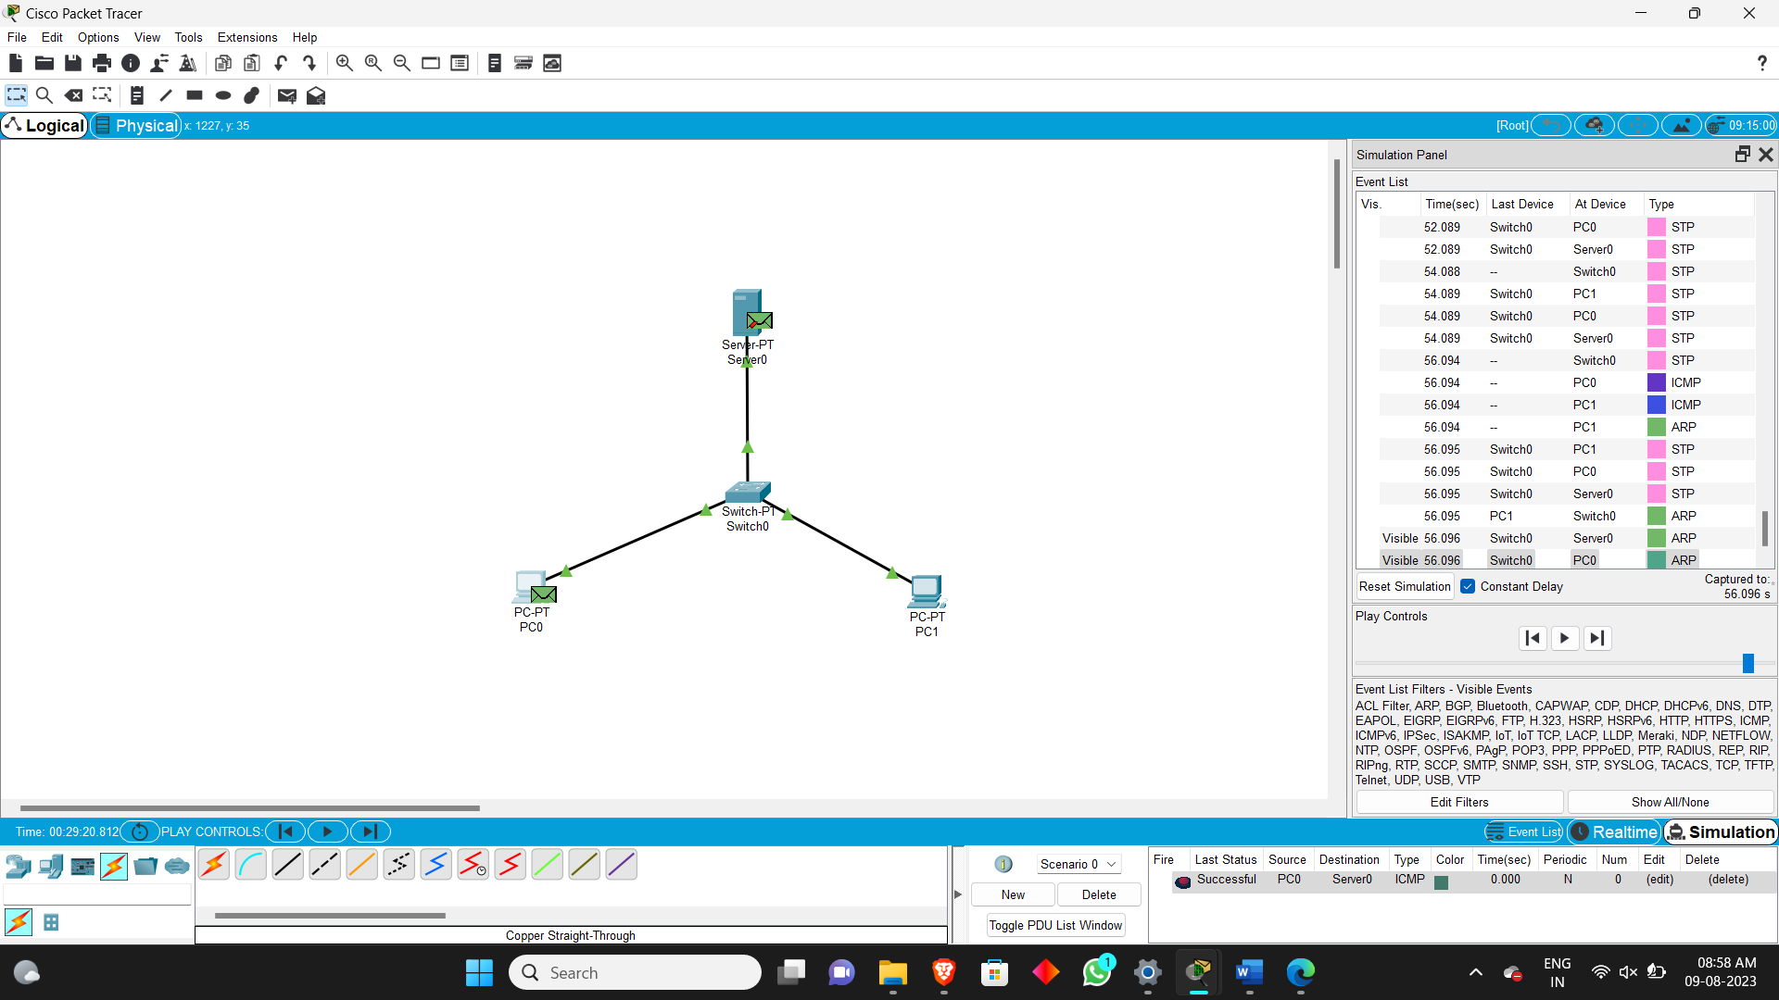

**Experiment -6 :-** Static Routing using Packet Tracer

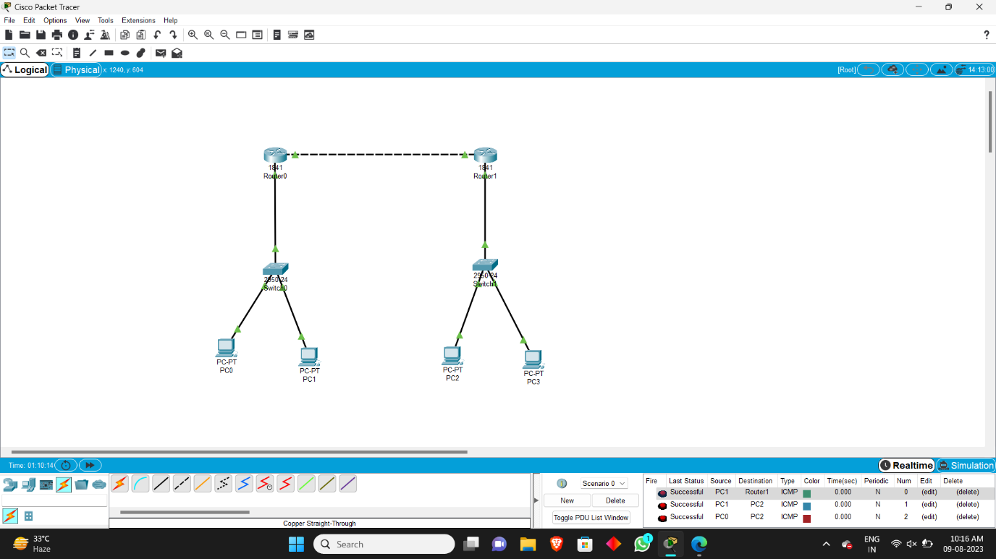

**Experiment -7 :-** Dynamic Routing using Packet Tracer ( OSPF)

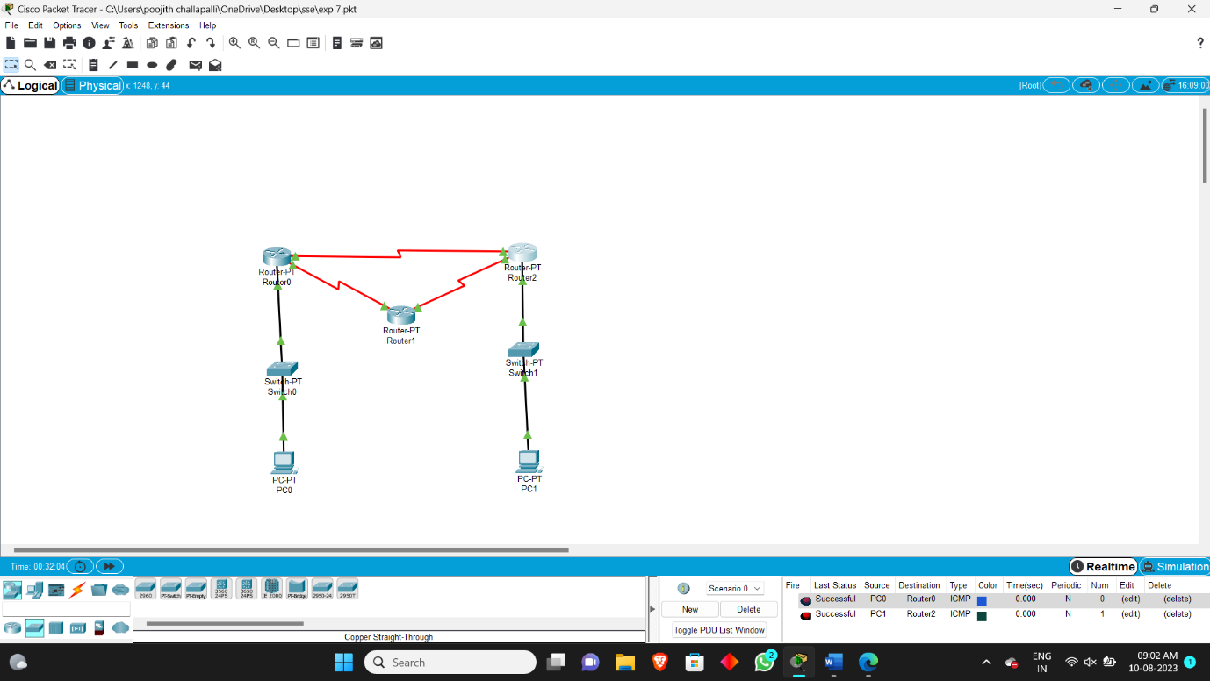

**Experiment -8 :-** Subnetting – Class C Addressing

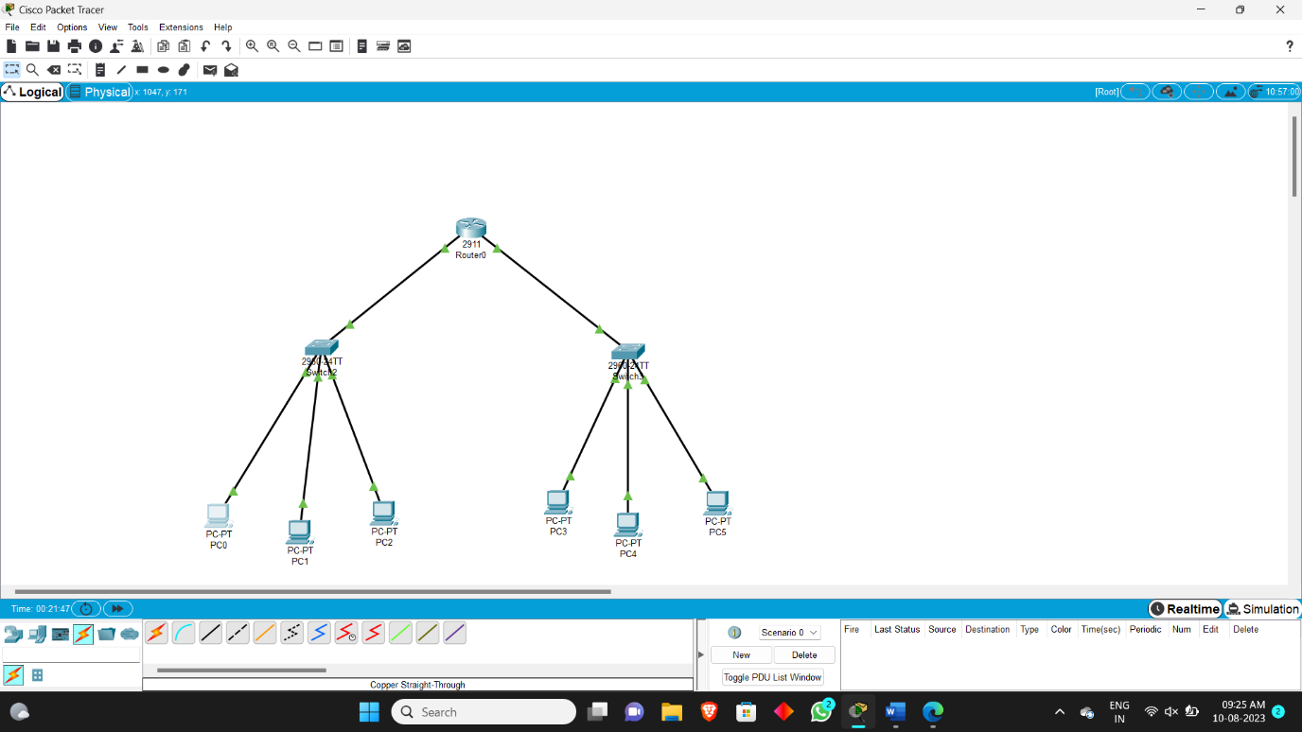

**Experiment -9 :-** Functionalities of TCP, UDP

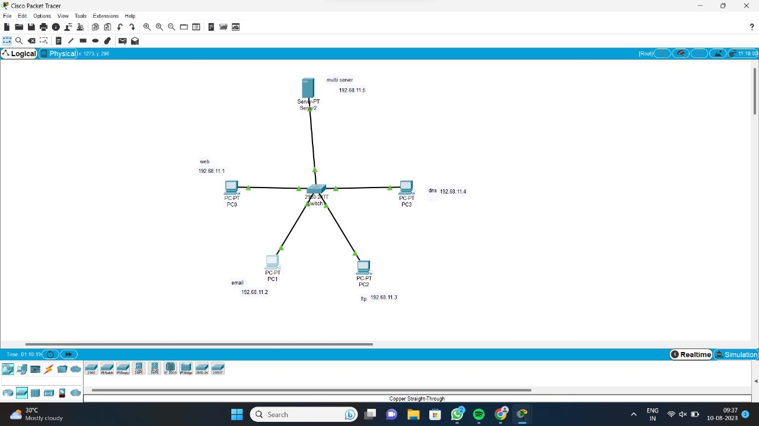

**Experiment -10 :-** TCP, UDP Exploration Solution



**Experiment -11 :-** IOT Based Smart Home Using Cisco Packet Tracer

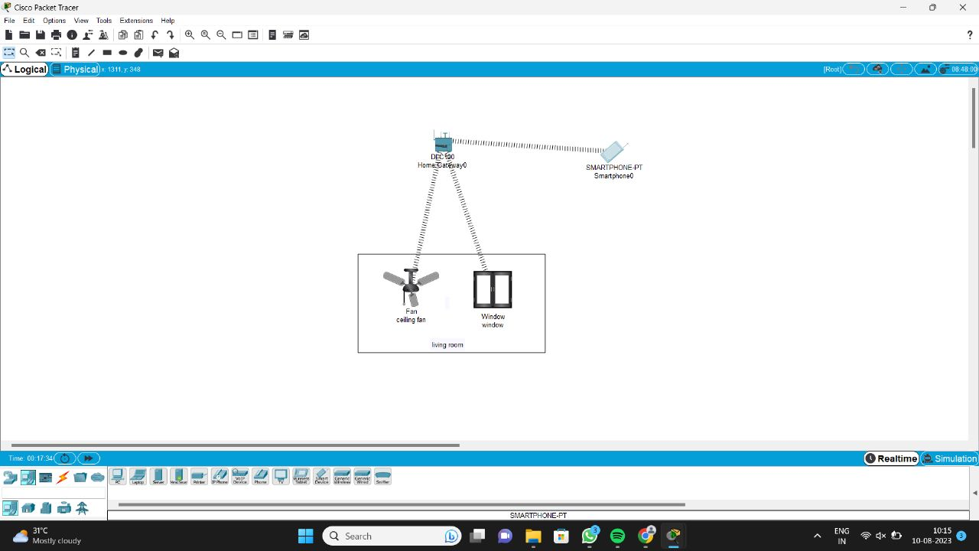

**Experiment -12 :-** Smart Garden in Cisco Packet Tracer

